1. In this lesson, our first exposure to **Maven by compiling and packaging** a simple maven project.
2. **POM.xml**: must be in the root directory of every maven project.
   1. Contains info for maven to compile and package our project.
   2. **<modelVersion>4.0.0</modelVersion>**: What version of object model, this POM is using. Not changes very frequently. But for the version of maven, we’re using, we need to mention.
   3. **<artifactId>**: The name of artifact that we’re going to generate with our project.
   4. **<groupId>**: Unique identifier for our organization or the group that is creating the project  
      NOTE: We use these artifact IDs and group IDs to pull down dependencies and plug-ins. So this is address or coordinate system that we talk about with maven.
   5. **<version>1.0</version>**:
      1. **If under development**: This is usually suffixed with “snapshot”
      2. **If Putting out a release for general availability:** “release”
   6. **<packaging>jar</packaging>:** Type of packaging such as Jar, War, Ear for the **artifact** that we produce
3. **Command**: mvn package 🡺
   1. **mvn:** tool
   2. **package:** **Phase** within the default life cycle would create a jar file containing the contents of our project.  
      NOTE: Everything phase preceding **package** phase such as compile, test would be executed.

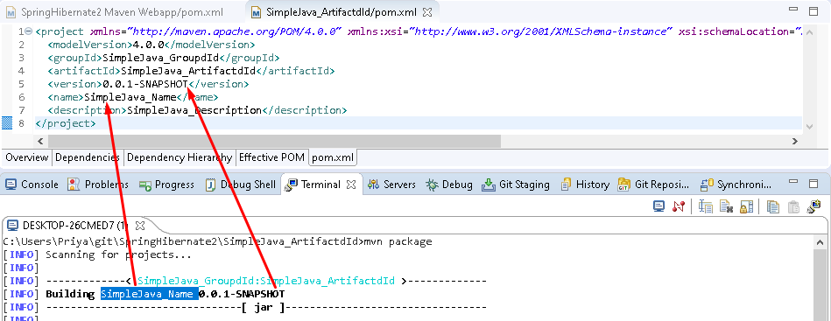  
**NOTE**: <name> is the name of the project in user readable form whereas <artifactId> is the actual name of the packaging file.

1. 